Award Tracking

Geoff Anderson G3NPA, Jim Hargrave W5IFP and Aki Yoshida JA1NLX

1.0 GENERAL

As yet more new ADIF fields have been introduced and the logbook database has had to be changed to accommodate the changes. The point of the changes becomes obvious once the user appreciates that now he/she can record the QSL "Submitted" or "Granted" status for more than just one award. It is left to the user how they actually employ the new Submitted and Granted flags but for the purpose of this Helpfile it will be assumed that "Submitted" indicates that cards or whatever proof is required has been sent in for adjudication by the award issuing authority and that "Granted" indicates acceptance of the claim made for a particular contact.

One can now track progress towards gaining the following awards:

AJA, CQDXFIELD, CQWAZ_MIXED, CQWAZ_CW, CQWAZ_PHONE, CQWAZ_RTTY, CQWAZ_160M, CQWPX, DARC_DOK, DXCC, DXCC_MIXED, DXCC_CW, DXCC_PHONE, DXCC_RTTY, IOTA, JCC, JCG, RDA, WAB, WAC, WAJA, WAS, WAZ, USACA and VUCC.

The confirmations required may come from up to 4 different sources;

  - QSL cards;
  - LoTW;
  - eQSL; and/or,
  - A "Special" category,

and can be combined if allowed.

It should also be appreciated that this capability is for award tracking and NOT QSL tracking. This functionality will NOT show how QSLs have been generated and/or distributed.

The enumerations now available in Logger32 are:

  - W = Entity has been contacted and there is an entry in the logbook;
  - C = Entity has been actually confirmed by a QSL card, LoTW, and/or eQSL;
  - S = The contact has been submitted for adjudication towards an award; and,
  - G = The contact has been accepted and credited to the award.

The above enumerations are added automatically as a result of other user actions detailed below.

2.0 BASIC SETUP

It is unlikely that each operator will want to track more than just a few of the offered awards. As a result, and in order to cut down on the large number of possible selections that can be made, users can select the awards they wish to track. Select the Logger32 Main menu items "Tools | Awards Setup | Awards to Track" to display the Awards to Track dialog box:

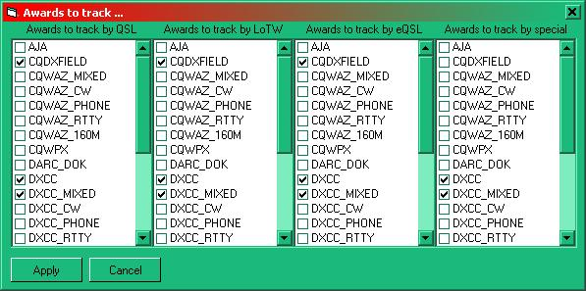

ATK_1

3.0 TRACKING YOUR AWARDS

3.1 Marking the QSOs

The standard practice of marking the QSOs with QSL information has not changed so the "W" and "C" enumerations are exactly as described in the Worked/Confirmed window topic. However the QSL tracking information is added on an individual QSO basis. Right-click on a QSO in the Logbook Page Window to display the menu:

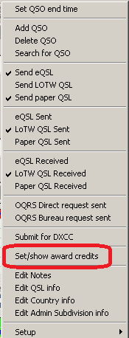

ATK_2

and select the" Set/show award credits" menu item to display the Award Status dialog box for the selected QSO.

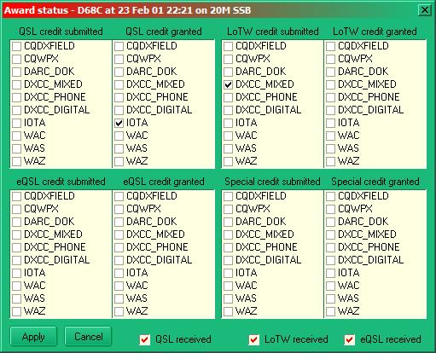

ATK_3

Now select the appropriate award confirmation source and submitted or granted status as appropriate. It is also possible to mark receipt of QSLs in this table. Select the <Apply> button to enter the Award Status data.

Some simple error checking is performed at this stage. For example, if a credit/granted submission is entered without Logger32 having been told of the corresponding receipt of a QSL, then Logger32 will generate an error message.

The "Special" credit granted/submitted areas are for use when something does not quite fit the normal. One such example might be the one case where IOTA do NOT require an actual QSL card and that is if contacts can be confirmed from submitted IOTA contest logs. Recording these cases in the special section will keep things in order.

Note: ADIF file import/export will process the GRANTED and SUBMITTED fields as well as the APP_LOGGER32_GRANTED and APP_LOGGER32_SUBMITTED fields. As Logger32 keeps track of the GRANTED/SUBMITTED type (QSL, eQSL, LoTW, Special) this additional information would be lost using only the GRANTED/SUBMITTED fields. Importing an ADIF file from a source other than Logger32 will put all GRANTED/SUBMITTED contacts into the Special category.

In this dialog box it is also possible to see the effect of selecting the awards to track. Each of the eight lists hold only a fraction of the awards available for tracking and this reduction is a result of the selection process detailed in section 2.0.

3.2 Flagging and Exporting QSL Award files.

Logger32 can export a DXCC.ADI file containing a list of QSOs when a confirming QSL card has been received. This file is similar to the eQSL and LoTW export files. The DXCC export file may be used for submitting QSL cards for verification. Note that this file will be in Date order and the cards must be sorted to match the file.

This file can be created using one of two procedures:

  - Enter the callsign in the Logbook Entry window or highlight a QSO in the Logbook Page window to display contacts in the Previous QSOs window. Right click on the QSO in the Previous QSOs window and select "DXCC submission flagged" on the Quick QSL dialog box. This will flag the QSO for a DXCC export file; or,

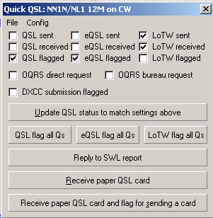

ATK_8

  - Set the flags by right clicking on the highlighted QSO in the Logbook Page window and selecting: "Submit for DXCC". This will automatically flag the QSO for a DXCC export file.

ATK_2

To export the DXCC.ADI file, select the Logger32 Main menu "File | Export files" menu items and select "Export DXCC File"

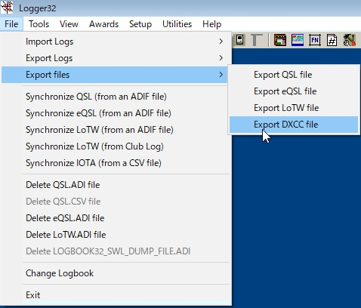

new ATK_10

This brings up the Export DXCC records dialog box where the user can select the operator and a filename.

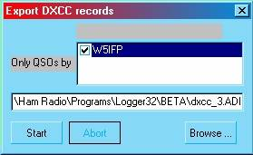

ATK_12

Following the export, the user will be presented with the DXCC export complete dialog box with two options for setting the flags:

  - Delete DXCC export flags from the logbook. This option deletes the flags after the DXCC export file is created: and,

  - Flag QSOs as submitted for DXCC credit. This option will check the appropriate submitted boxes on the Award Status dialog box (ATK_3).

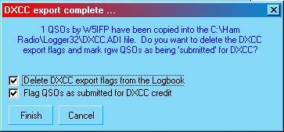

ATK_11

If the "Flag QSOs as submitted for DXCC credit" check box is checked, the award table will be set based on the following logic:

  - All QSOs - If the QSO does not have the DXCC granted flag set, the DXCC submitted flag is set.

  - All QSOs - If the QSO does not have the DXCC_MIXED granted flag set, the DXCC_MIXED submitted flag is set.

  - CW QSOs - If the date is a valid date for DXCC_CW and if the QSO does not have the DXCC_CW granted flag set, the DXCC_CW submitted flag is set.

  - SSB, AM and FM QSOs - If the QSO does not have the DXCC_PHONE granted flag set, the DXCC_PHONE submitted flag is set.

  - All other mode (not CW, AM, FM, SSB) QSOs - If the QSO does not have the DXCC_RTTY granted flag set, the DXCC_RTTY submitted flag is set.

Note: If the granted flag is already set, then Logger32 does nothing.

3.3 Viewing the results in the Awards Table

The results are viewed using the Logger32 Awards menu (in this example the IOTA menu item was selected), displaying the IOTA Award table.

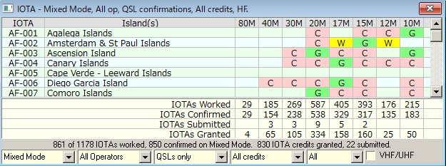

new ATK_4

The example in ATK_4 shows the "Granted" IOTA QSL as shown entered in ATK_3 above when viewed in the IOTA Award table. Note also that the entry for AF-003 shows a "Granted" marking (with a different highlight color) .

Clicking on a W/C/S/G cell on an award table (of an ADIF-defined Award) will open the Generic QSOs window. However, if the Highlight credit option is enabled, the SUBMITTED and GRANTED highlights will be filtered based on the Credit selection option on the Award Table.

Note: There are up to five filter selection drop down lists at the bottom of the Awards table: Mode selection; Operator selection; QSL Type selection, and QSO credit status (see ATK-6 below). The fifth pane is not visible on all Awards tables and the contents vary depending on the table selected.

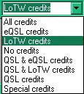

ATK_5

There is one area that needs to be brought to the attention of the user concerning the DXCC table when displayed using the DXCC-CW filter. The ARRL does not recognize CW contacts before 1 Jan. 1975 for the DXCC CW award so this table alone contains that date restraint. Users will note that when calling up the entry in the DXCC_CW totals the overall country window shows the contact as confirmed "C" while it is shown as "W" in the award stats window.

4.0 AWARD TABLES HIGHLIGHT COLORS

The Submitted and Granted credit highlight colors in the Award tables may be set using the Logger32 Setup menu items: Highlight | Credit highlight | Choose credit submitted highlight color as shown below.

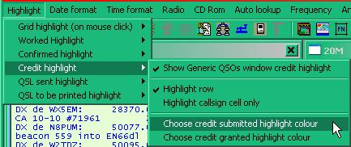

ATK_6

5.0 DX SPOT TABLE WORKED/CONFIRMED/CREDIT HIGHLIGHT SELECTION

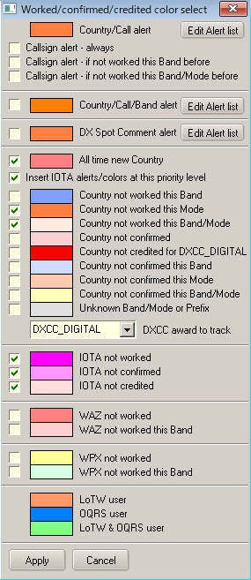

new ATK_7

The entry "Country not creditted for XXXXX" 6 from the top of the table is determined by the selection made in the pane below the entry for unknown band/Mode. In this particular example the highlight color depicts "Country not credited for DXCC_DIGITAL MIXED". The caption will follow the award selection

Note that "Credited" and "Confirmed" are not the same thing. "Confirmed" indicated that you have received confirmation in some form from the QSO partner. "Credited" indicates that the contact has been adjudicated and included in your credits for the award in question.

The award selection (DXCC, DXCC-MIXED, etc.) has no priority. Whatever is selected is what it is - Credits (no matter how many, or what specific DXCC they may be for) are ignored unless they have been applied to the specific DXCC award selected.

6.0 QSL UPDATE FOR DXCC/IOTA AWARDS

This function allows users to do batch updates of QSL status and convert them from "Submitted" to "Granted'. DXCC and IOTA awards are supported. The function is accessed by selecting the Logger32 Main menu Awards menu item.

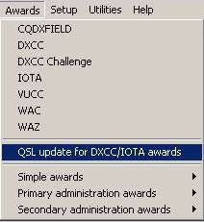

ATK_13

6.1 DXCC Update

The following chart is representative of a list of QSOs in the logbook that have been submitted to the ARRL for credit toward an award. To update the status to Granted, the user must place a check in the box by the applicable QSOs. After all the affected QSOs have been checked, click on "Mark checked QSOs as granted". The checked QSOs will then be automatically updated in the logbook.

Note: If you have many records listed, you can click on "Check all" after you have verified acceptance by ARRL.

Note: For QSO records to show on this list, a QSL Card must be received and flagged as Submitted on the "Set/show awards credits" chart (See paragraph 3.1 above).

QSL/eQSL/LoTW QSLs received flags cannot be turned off if awards have been submitted/granted,

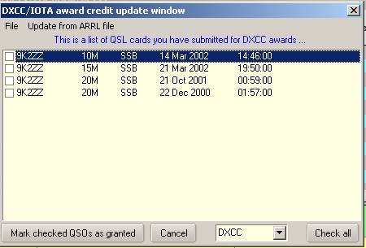

ATK_14

Automatic Updates are also available from the ARRL by selecting the menu: Update from ARRL file.
To initiate the auto-update process, select "Update from ARRL file". Insert the Path/filename of the ARRL file. This file can be downloaded automatically using the supplied "ARRL scraper.exe"

Note: See the ARRL Scraper topic for obtaining a file from ARRL and details for automatic update.
The following depicts the screen where the file Path/Name is entered. This pane provides for a full update or just adding new credits.

Click "Start" after you have made your selections.

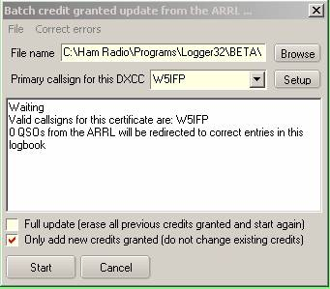

ATK_15

If you have more than 1 callsign linked to your primary callsign, select "Setup" and the system will list all operator callsigns found in the logbook. Delete all calls not linked to the master callsign.

Clicking on the "Operators" button will get all the operators in the selected logbook. Of course, if you have mixed and matched DXCCs all in one logbook, then this probably isn't the best option to click.

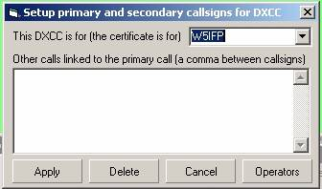

ATK_15A

Once the process is started you can observe the Logger32 progress bar and the update window will display action as each record is processed. The following 2 screen captures depict a typical process.

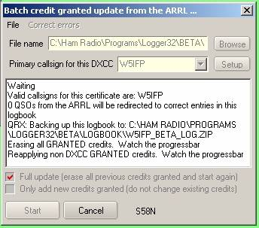

ATK_16

When doing a "Full update" (first time around if you like) of ARRL statistics, the Logger32 statistics dataset is reconstructed without ARRL/DXCC information - Non-DXCC credits are then reapplied to the statistics and the download process is.

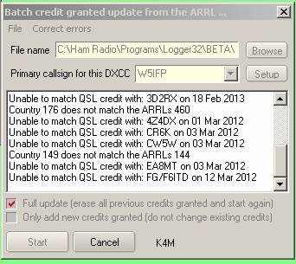

ATK_17

Once all the records have been processed, the chart will display "Done"?.

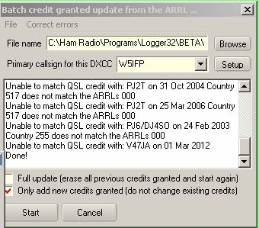

ATK_18

As soon as the complete file is processed, you will be presented with a message showing how many QSOs were updated and how many were not updated.

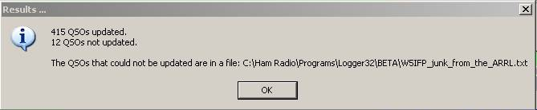

ATK_19

You can click on the "Let me try" button and Logger32 will attempt to find a match. If no match is apparent, you will be presented with the following notice:.

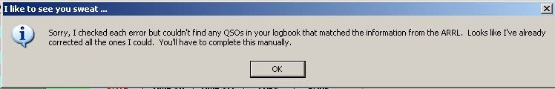

ATK_20

Having failed to find any direct match, the user can manually update the QSOs. Click on the upper tab "correct error" and you will be presented with a chart that shows the ARRL records from the reject file. These are the records where a complete match could not be found.

Click on these records and a possible match from the Logbook will be posted on the right side of the window. If you find the correct record listed, click on it (right side of chart) and that QSO in the logbook will be updated.

Note: You may have to check the "Ignore DXCC" and or one of the other options to get down to the correct QSO record. When you select all possible matches click SAVE. This updates the ARRL file.

Note: In order to update the Logbook records you must repeat the update cycle. Click Start on the "Batch credit" table and be sure the option "Add only new credits granted" is checked. This process may have to be repeated several times until all records are mapped to the correct QSO.

Note: If you can't figure out what the text means (there's some weird stuff sometimes) for an entry in the left list, right click on the record in the left row and this will take you directly to the QSO record at the ARRL. You can see for yourself what the ARRL says for the QSO. You will be prompted to login to LOTW, and then the QSO record will be displayed.

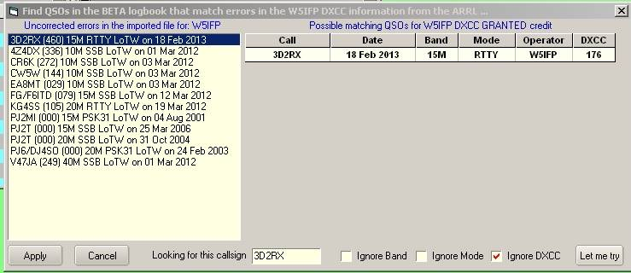

ATK_21

Note: The first time this process is used, extensive manual correction/editing may be required. In the case of some of the Beta testers, as many as 300 credits had to be manually corrected/edited using the window provided. Once all errors in the ARRL data have been mapped to match correct QSOs in the users log, it should be plain sailing from then on out.

6.2 IOTA update

The update procedure is the same as the DXCC manual update. As yet this processes has NOT been automated. IOTA Updating will be manual but if the operator has marked his log as "QSO Submitted" for each claim these will be listed and all he/she has to do is to check them off one by one from a list of approved IOTA QSOs.

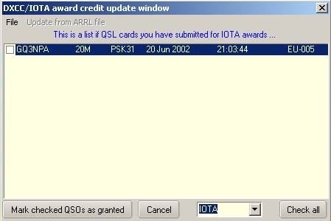

ATK_22

To obtain a list of credits the user can Log-on to the RSGB IOTA web site and if you are registered sign in to your account. From the menu list select "My IOTA My Credits" and at the bottom of the QSO summary section click on "Download QSOs (CSV) Download my QSOs as a CSV file".

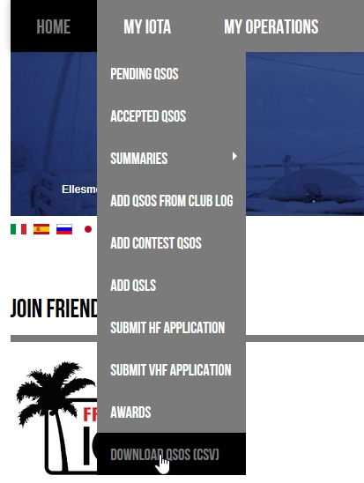
new ATK_23

One receives a file that looks like the following when opened in a text editor:

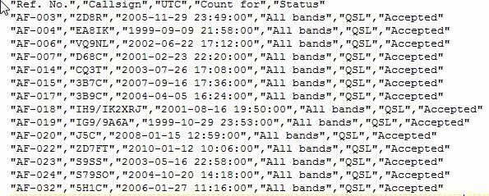

ATK_24

The following is representative of the file when opened in Excel.

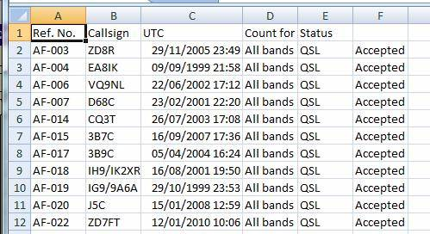

ATK_26

